CS530 Project Team Info Sheet

Chris Harhay, Jeff Blankenship, Taylor Somma

Prof. Kurkovsky

8 Sept 2016

**Bobcat Technology**

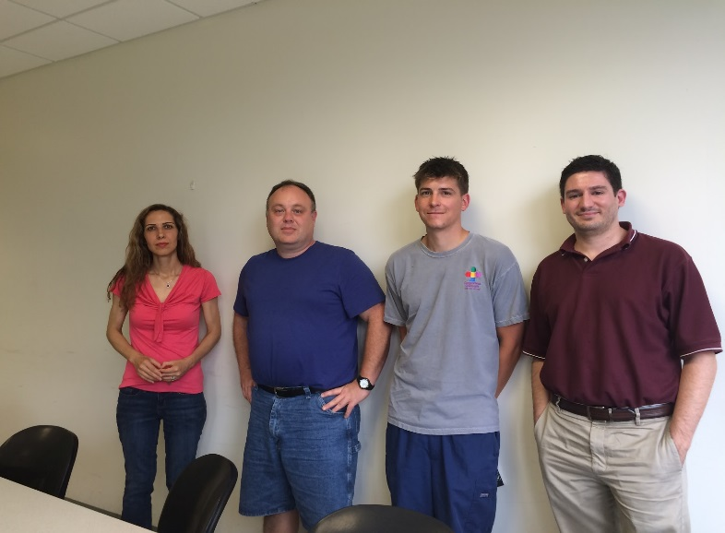

A diverse team of high tech experts.  We bring together the combined strengths of a broad range of backgrounds and experience, ready to tackle any challenge.

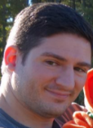  
**Chris Harhay** graduated from Penn State University with a Bachelor of Science in Operations & Information Systems Management. He has over a decade of experience supporting electronic health record systems and their data. He was a Senior Systems Analyst for St. Francis Hospital in Hartford before joining ProHealth Physicians in 2014 as a Senior Database Administrator, Architect, and Developer. Chris has a passion for programming and helping others to make sense of data. He lives in South Windsor with his music teacher wife Olga, their energetic one-year-old son Alex, and two rescue dogs Lily and Carly.

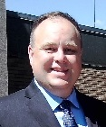  
**Jeff Blankenship** is a former Naval officer with a degree in Computer Science from the US Naval Academy.  His experience includes project development and lifecycle management for submarine sonar and fire control systems.  In this capacity, he developed and validated specifications and requirements as well as testing procedures and acceptance criteria.  As the Director of Officer Training for the Naval Submarine School, New London, he coordinated the acquisition and implementation of computer based training simulations for submarine navigation and control systems.  Now retired from the Navy, Jeff is attending CCSU to update his education with an M.S. in Software Engineering.

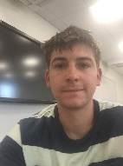**Taylor Somma** is an EEG Technologist with a degree in Molecular and Cell Biology from the University of Connecticut. He is currently working towards an M.S. in Computer Information Technology at CCSU. His experience in software development includes an apprenticeship with the A100 program where he worked with a team of 5 developers to create a prototype web application for Insite Analytics.

The team’s first meeting was held 07 Sep 2016. During this meeting the team discussed roles and responsibilities as well as division of labor and other aspects of team organization.

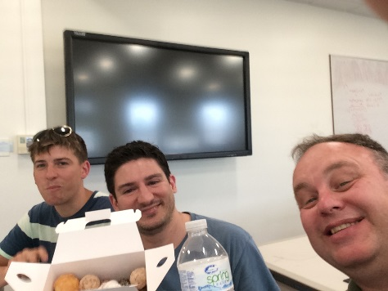

During this meeting the team formed the following:

**Team Agreement**

1. We will communicate by email, phone, and in person as needed as the project progresses.  Team members will make every effort to respond to emails within 24 hrs.  In the event that a team member will be out of contact for an extended period, they will notify the rest of the team beforehand if possible.
2. The team will hold mandatory meetings immediately following each Wednesday’s class.  This is meant to be a short face-to-face update on current projects, approaching deadlines, and scheduling for the following week.
   1. Additional meetings, either online or in person, will be scheduled by mutual agreement as needed.
   2. Specific requirements such as preparation, location, documentation, etcetera will be determined as the need arises.
3. The team will maintain a Team Notes thread on GitHub.  Each member will review this and add any notes from the meeting.  This will serve as a bulletin board of current projects, status, deadlines, and planned meetings.
4. Division of Work:  The team’s workload will be divided into logical units and assigned by mutual agreement to specific team members.  The team member taking on a work unit will do any required research, take notes, and prepare the final product.  Other team members will assist as needed.  All team products will be posted or shared among the team for proofreading and feedback before submitting.  GitHub will be the primary tool for sharing and collaboration
5. Version Control:  We will familiarize ourselves with the collaboration tools of GitHub and make use of them to document all feedback and version changes.  The team member assigned for that unit will commit any feature additions and bug fixes. Log messages will be maintained and will describe what the bug or feature altered was.
6. Group Effort:  While each project will be organized by an assigned team member, all team members will participate and receive joint credit for each item.
7. Contingencies:
   1. Each member of the team accepts responsibility for their own work.  All work submitted will be original product, with proper citations and references.  University policies concerning academic integrity will be followed.
   2. In the event that a team member withdraws from the class, becomes unreliable, or is suspected of academic dishonesty, the team will make every effort to resolve the issue within the team.  If internal resolution is not possible, instructor intervention or advice will be sought.
8. Team contact information:

Jeff Blankenship  (instructor contact)

Email: [jeffrey.blankenship@my.ccsu.edu](mailto:jeffrey.blankenship@my.ccsu.edu)

Phone: 860-304-9386

GitHub ID:  JeffBship

Chris Harhay

Email: [chris.harhay@my.ccsu.edu](mailto:chris.harhay@my.ccsu.edu)

Phone: 860-335-6586

GitHub ID: chrisharhay

Taylor Somma

Email: [taylor.somma@my.ccsu.edu](mailto:taylor.somma@my.ccsu.edu)

Phone: 860-965-6366

GitHub ID: UC89